1. M1_Trans_Amp_labnotes

6. Measurement exercise
M1. Investigation of common emitter amplifier

a.

Ue 0.656V
Ub 1.288V
Uc 0.712V

Base-emitter voltage: $U_{BE}=U_{B}-U_{E}$
- $U_{BE}$ = 1.288 V - 0.656 V = 0.632 V
Collector-emitter voltage: $U_{CE}=U_{C}-U_{E}$
- $U_{CE}$ = 0.712 V - 0.656 V = 0.056 V
Si: 0.5-0.7V

Base-Emitter Junction: Note that the calculated $U_{BE}$ of 0.632 V falls squarely within the expected 0.5 to 0.7 V range, confirming the BC182 is a silicon transistor and its base-emitter diode is correctly forward-biased

b.

start deform: input vpp: 152mV (saturation)
(the output gets its lower bound capped)

c.
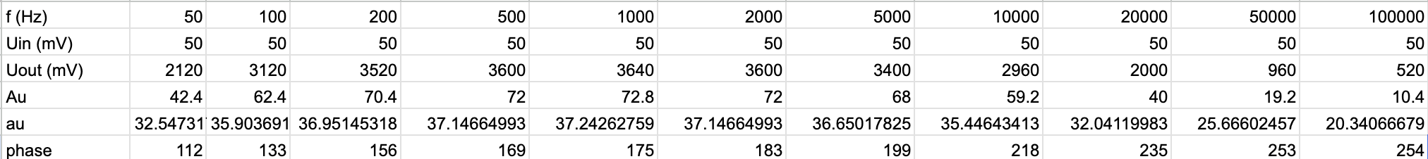
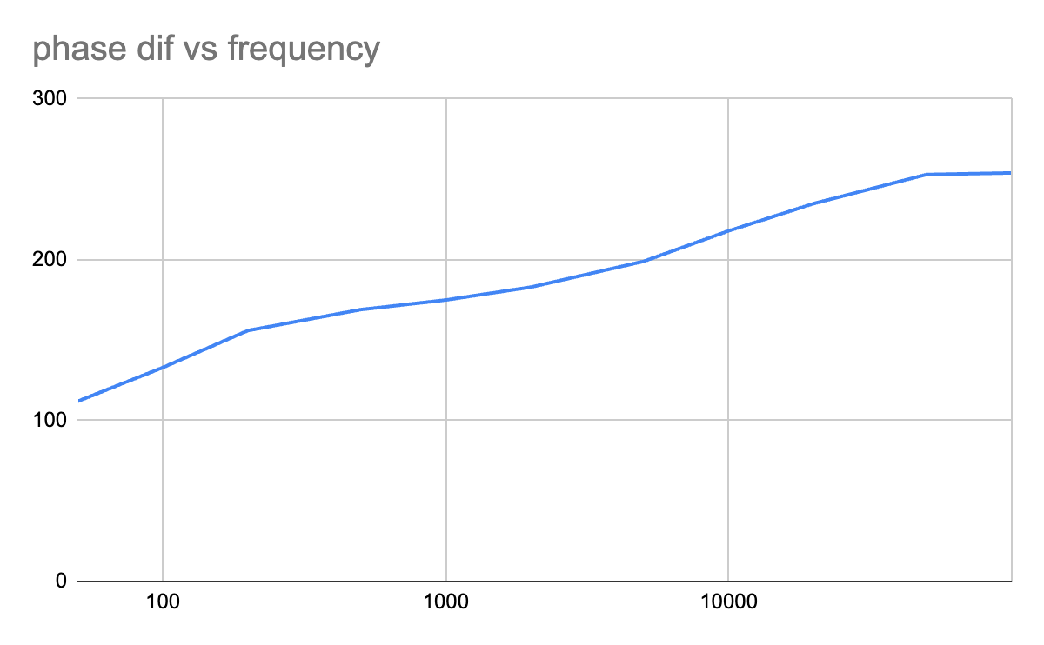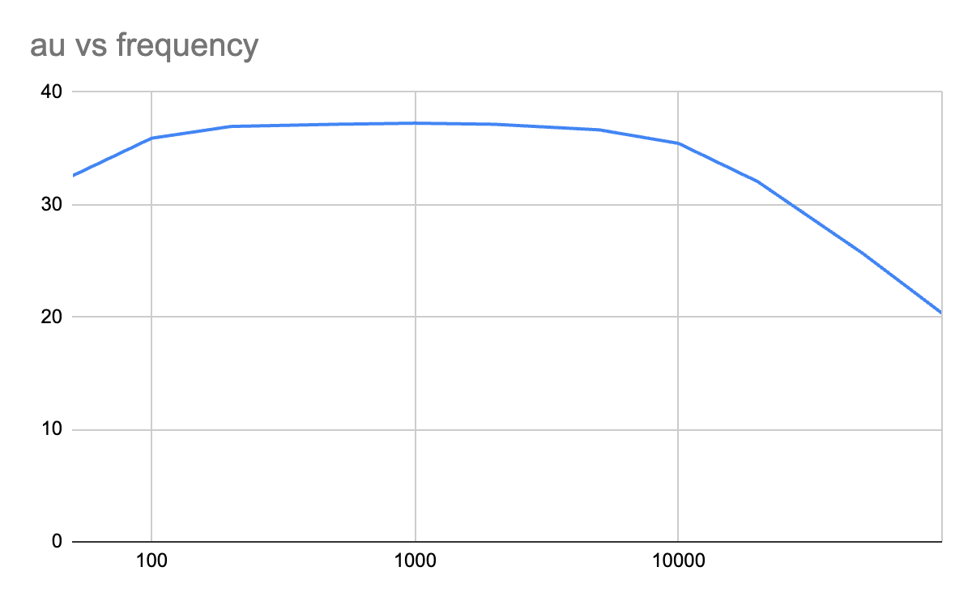
d.

cutoff voltage: ($3640mV×\frac{1}{\sqrt{2}}$) = $2574mV$
lower cut-off frequency $f_{l}$: 66Hz
upper cut-off frequency $f_{u}$: 12580Hz
Broadband width: $12514Hz$ ($B=f_{u}-f_{l}$).

e.
Noticed that our capacitor was there the whole time
so instead of redoing, we do e without the capacitor

cutoff voltage: ($3640mV×\frac{1}{\sqrt{2}}$) = $2574mV$
upper cut-off frequency $f_{u}$: 82800Hz

The 12500Hz cut-off our team measured earlier was severely limited by the Miller effect, where the voltage amplification multiplied the effect of the C3 capacitance.
By removing C3, we eliminated the feedback capacitance that was being multiplied by the amplifier's voltage gain, allowing the high-frequency bandwidth to expand drastically.

f.

cutoff voltage: ($3720mV×\frac{1}{\sqrt{2}}$) = $2630mV$
upper cut-off frequency $f_{u}$: 217.8kHz

The significant increase in the upper cut-off frequency occurs because the cascade circuit fends off the Miller effect. In this configuration, the base of transistor $T_{1}$ is connected to a DC voltage. Consequently, the capacitance no longer plays a role in limiting the frequency response because it is not multiplied by the voltage amplification. Additionally, installing the second transistor ensures that the output voltage will not be drained from the collector of $T_{2}$.

M2. Investigation of common collector amplifier
input Vpp: 1V
a.
output Vpp: 780mV
phase shift: 0
$A_{u}=780/1000=0.78$.

b.

 | 100 | 1000 | 10000 | 100000
Out Vpp (mV) | 780 | 780 | 780 | 780 | 780
phase | 0 | 0 | 0 | 0 | 19
Au | 0.78 | 0.78 | 0.78 | 0.78 | 0.78

c.
Maximum output was 780 mV, half output 390 mV
resistance between a,b: 69.5kohms = Rin

d.
Maximum output: 864mV, half output: 432mV
resistance between a,b: 309.3kohms = Rin

The Observation: The input resistance increased massively—from $69.5kΩ$ in the standard setup to $309.3kΩ$ in this new configuration.
The Explanation: By changing the jumpers, you configured the circuit as a "bootstrapped" voltage follower. This setup feeds a portion of the output signal back into the base biasing resistors. Because the AC voltage across the biasing resistor is minimized, very little AC current flows through it, effectively making the input resistance appear much higher to the incoming signal. This is highly desirable because it prevents the amplifier from loading down whatever signal source is connected to it.

